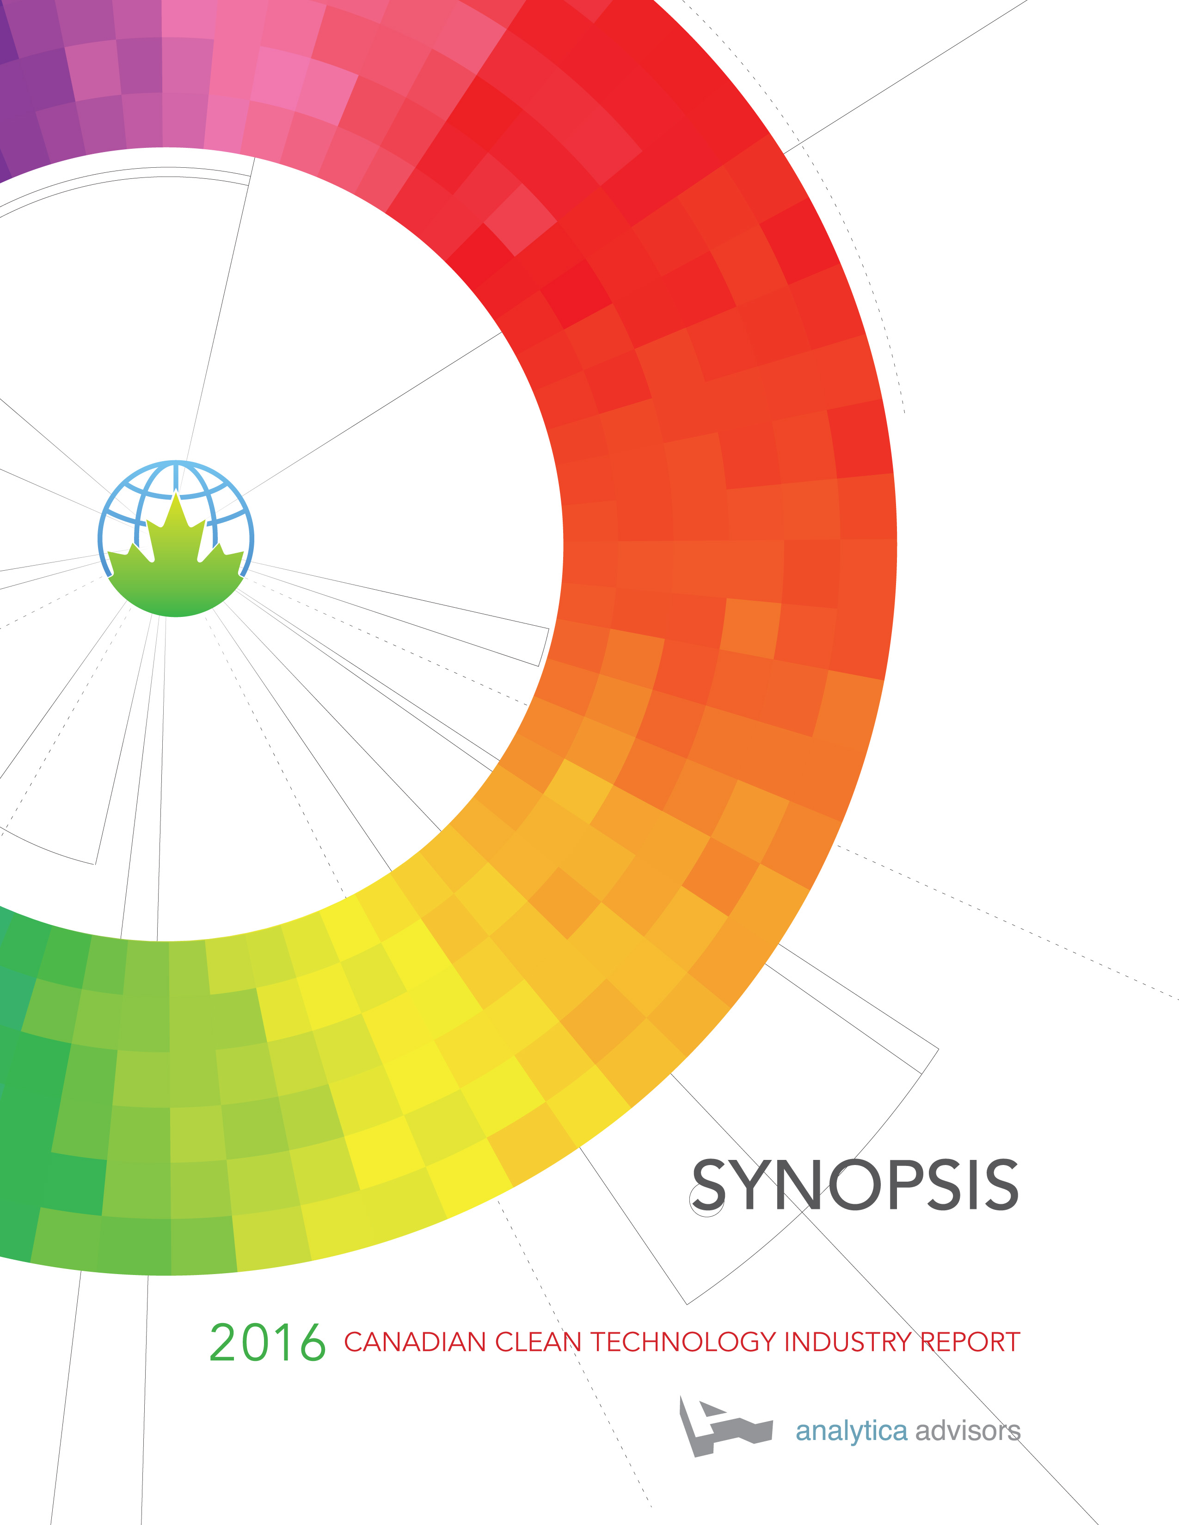

2016 CANADIAN
CLEAN TECHNOLOGY INDUSTRY
REPORT

Synopsis

The Paris Agreement, Clean Growth and the Canadian Clean Technology Industry
The Paris Agreement, the first ever universal, legally binding climate agreement, is due to enter into force in 2020. It heralds the dawn of a new era as we work at home and abroad to limit global warming to less than 2°C and to pursue efforts to further limit global warming to 1.5°C above pre-industrial levels.

The Paris Agreement was followed by the Vancouver Declaration on Clean Growth and Climate Change, which reiterated Canada’s commitment to the Paris Agreement; calling for significant reductions in GHG emissions based on Canada’s Intended Nationally Determined Contribution (iNDC) of a 30 percent emissions reduction from 2005 levels by 2030. Reiterating the Paris Agreement, the Vancouver Declaration recognized the requirement for global emissions to approach zero by the second half of this century and called on indigenous peoples and other economic actors including environmental non-governmental organizations (ENGOs), businesses, financial institutions and municipalities to be mobilized to address the challenge of climate change.

In the Vancouver Declaration, Canadian political leaders made a commitment to clean growth. In doing so, they accepted the challenge of writing a new playbook of policies calling upon us all to re-imagine how public and private investments address our hope for the economy and our commitments to the environment.

The Canadian clean technology industry is Canada’s first new industry of the 21st Century. It directly employs over 55,000 people in almost 800 firms. It is a highly competitive, innovation-led industry, committed to export and to investing heavily in R & D. It is an industry with a collective desire to solve problems to do with the air, water and earth. These companies are at a stage where they plow back revenues into hiring Canadians to build-out competitive positions in a fast growing global markets, not into paying dividends. These companies are creating and commercializing technologies that protect our environment while growing and diversifying our economy. They make economic renewal possible.

The Canadian clean technology industry can play a key role in the global race to fight climate change and help Canada meet its 2020 Paris commitments. And it can employ even more Canadians in good jobs with good futures, employing some of our brightest and best, and building the knowledge-based economy that Canadians hope for.

But, despite its impressive progress, growth in the clean technology industry is stalling. We need to rise to several challenges to ensure the opportunity to grow and diversify our economy AND meet our Paris commitments is not lost.

2016 Canadian Clean Technology Industry Report

The 2016 Canadian Clean Technology Industry Report, compiled and published by Analytica Advisors Inc., concerns itself with the people working in the growing number of businesses in the industry.

The 2016 report builds on six years of research conducted at the firm level, this year on a national cohort of almost 800 companies. At the core of this annual report, and the four that preceded it, are the companies that participated in the research. This year 107 companies, including 12 public companies and 95 private companies, shared their confidential financial information and plans with Analytica Advisors so that they can benchmark themselves against their peers in this report. Over the past 5 years, 293 companies or more than a third of the industry, have participated in this research. We would like to thank each of these firms for participating. It takes courage to both report on achievements and reflect on hard choices for the future. And it makes the primary research in this report unique in academic, private and public domains. Through this sharing and benchmarking, we can draw lessons on how to build new industries in the 21st century.

The research for the 2016 report was conducted in the summer and fall of 2015 and companies reported their results for 2014 and their plans for 2015.

For the second time, the report includes an analysis of Canada’s global market share ranking among the top 25 exporters of manufactured Environmental Goods, based on global trade reports. It also includes an analysis and ranking of the change in global market share for these top 25 global exporters.

This report is prepared for the exclusive use and information of those clean technology companies who participated in Analytica’s research; elected officials and their advisors with responsibility for finance, innovation, global affairs, energy, the environment and climate change; as well as private and public sector subscribers to the report.

What is clean technology and what is a clean technology company?

Clean technology is Canada’s first new industry of the 21st Century. It is much more than technology that produces renewable energy from the sun and the wind. In Canada alone, the innovation-based firms that make up the industry reported almost $12 billion in revenues and operate in one of 10 clean technology sectors.

These 10 sectors form the basis of the 2016 Canadian Clean Technology Industry Report and fall under three broad market segments — Upstream, Downstream, Water & Agriculture.

A clean technology company is defined as a company with proprietary technology or know-how that addresses one or more of the markets below:

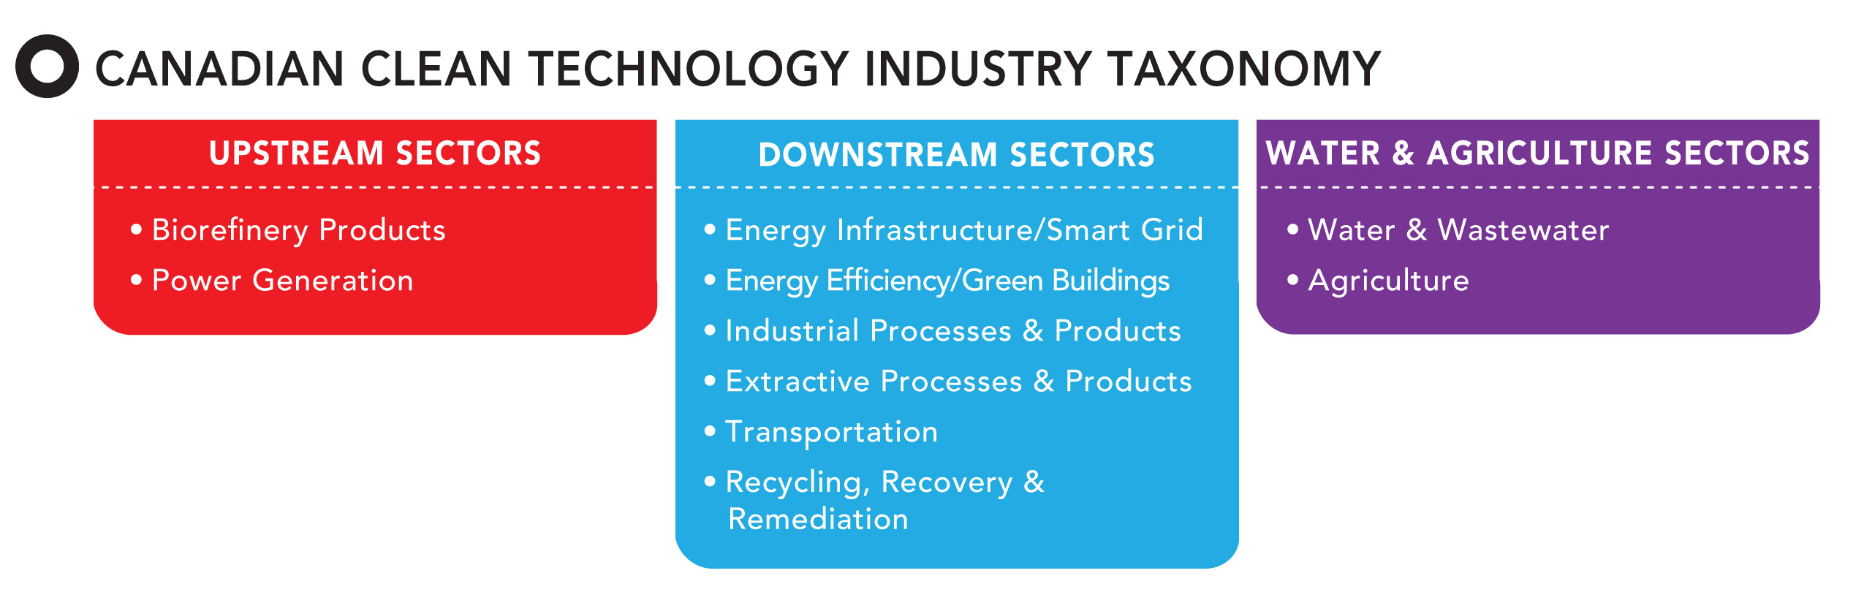

Clean technology: re-imagining our society

Like more established sectors of the economy, clean technology is now part of how we are re-imagining how our society works. At the same time, it is a technological and economic force that will create new systems to redefine how the world works as we face the challenges of climate change. Mitigating and adapting to climate change will require changes to existing systems to protect the air, water and land. Each of us, each of our families, are re-imagining our lives and how they will be different in a world where there are limits on what we can “throw away” into the air, water and the earth.

In the next 35 to 85 years, we will be faced with the challenge of moving to a world without fossil fuels. Replacing fossil fuel exports that now represent 20 percent of all of Canadian exports with other globally competitive goods and services will require time. Canadians support both acting on climate change and diversifying the economy. Clean technology offers the chance to do both: achieve Clean Growth and address Climate Change. It is not one or the other.

Though not yet obvious for us to see, new systems are being created so that we address climate change, and clean technology is part of these new systems. Without much fanfare, more than 55,000 people now work in Canada’s clean technology companies. Still in its infancy, Canadian innovation-based firms and manufacturers now export $14 billion around the world. So why haven’t more Canadians heard of it? It’s a new part of how we are re-imagining society, the environment and the economy.

Canadian clean technology companies and the Vancouver Declaration

The important work to build Canada’s plan to deliver on its commitments under the Paris Agreement will be organized under four working groups:

- Clean Technology Innovation and Jobs
- Carbon Pricing Mechanisms
- Specific Mitigation Opportunities
- Adaptation and Climate Resilience

There is also an ongoing initiative that will provide continuity for the work underway to support the Canadian Energy Strategy: Energy Efficiency and Clean Energy Technology and Innovation. The work will be done by teams made up of provincial, territorial and federal representatives and the plans they propose will be made public. The plans must be delivered in the Fall of 2016 when the First Ministers will reconvene.

The Vancouver Agreement set out a process to which the women and men of Canada’s clean technology industry can contribute to building and delivering Canada’s plan for Clean Growth and Climate Change. Canadians working in clean technology firms will have the opportunity to contribute their expertise and experience to these groups and to explain how their company can contribute to clean growth and to Canada’s climate change plan.

The good news

The Canadian clean technology industry now has over 775 technology companies, including many SMEs, operating in ten sectors and in every region of Canada. To put this in context Canada has 700 firms in the aerospace sector and 450 firms in the automotive sector.

The industry continues to gain traction as a significant contributor to the Canadian economy in terms of revenues, employment and exports.

In 2014, industry revenue was an estimated $11.63 billion and clean technology companies directly employed 55,600 people, compared to 49,900 in 2013.

Export revenues for the clean technology industry exceeded the halfway mark in 2014 and were approximately $6.6 billion, with 23 percent of export sales coming from non-US markets.

87 percent of Canadian clean technology companies were exporters, and 91 percent anticipate exporting goods and services by 2016.

Companies are accelerating the move away from business models of one time sales and are moving strategically towards recurring revenue business models. In 2014, the percentage of sales coming from one time sales fell from 54 percent to 45 percent, while turnkey solutions rose from 37 percent to 44 percent.

The same companies are investing in innovation, spending over $1.2 billion in R&D in 2014 and $7.6 billion cumulatively from 2008 to 2014, of which $5.5 billion was from firms with less than $50 million in revenue.

The not so good news

For the first time in this series of annual reports, the overall industry showed slowing growth in 2014, due to capital constraints and sluggish global markets beyond the US. Revenues decreased 3 percent on a compound annual growth rate (CAGR) for 2012 to 2014.

Growth in industry employment also slowed and grew 2 percent year on year from 2013 to 2014 and 3 percent CAGR from 2012 to 2014.

80 percent of the industry’s companies are at initial scale-up stage or later, when access to debt and project finance becomes more critical to enable sales of profitable turnkey solution. Such finance is not readily available from Canadian sources today.

With a CAGR of 8 percent from 2005 to 2014, global trade in clean technology exports doubled during this period to reach over $1 trillion. But Canada’s market share of manufactured environmental goods declined by 35 percent from 2.0 percent to 1.3 percent. Among the top 25 exporters, our global ranking fell from 14th to 19th.

Canada is not alone in feeling the heat as the two charts tracking recent changes in both export and trade in manufactured environmental goods show. At current growth rates the US will soon overtake Germany as the world’s second largest exporter of manufactured environmental goods, while top ranked China continues to dominate global trade with 18% of trade versus second ranked US at 11%.

Similarly, with lower than average growth in both exports and trade of manufactured environmental goods, the UK is poised to be overtaken by Singapore in the list of top 12 global exporters, and may be overtaken by Canada as the world’s 10th largest trader.

But the essence of the matter is that after Japan and the United Kingdom, Canada’s is the steepest decline in global market share among top exporters. For Renewable Energy and Energy Efficiency manufactured environmental goods, Canada has lost 39 percent of its 2005 market share and is the biggest loser of market share among the top exporting countries.
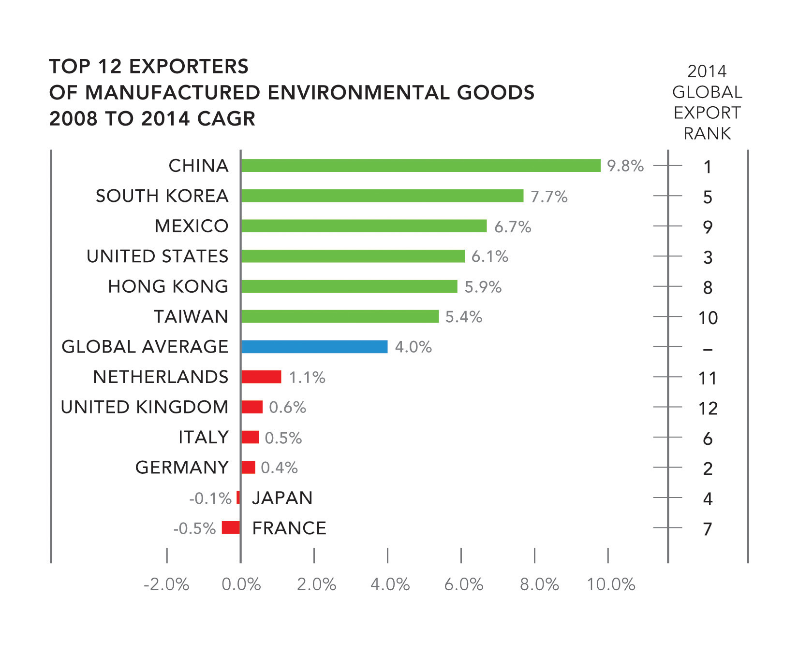
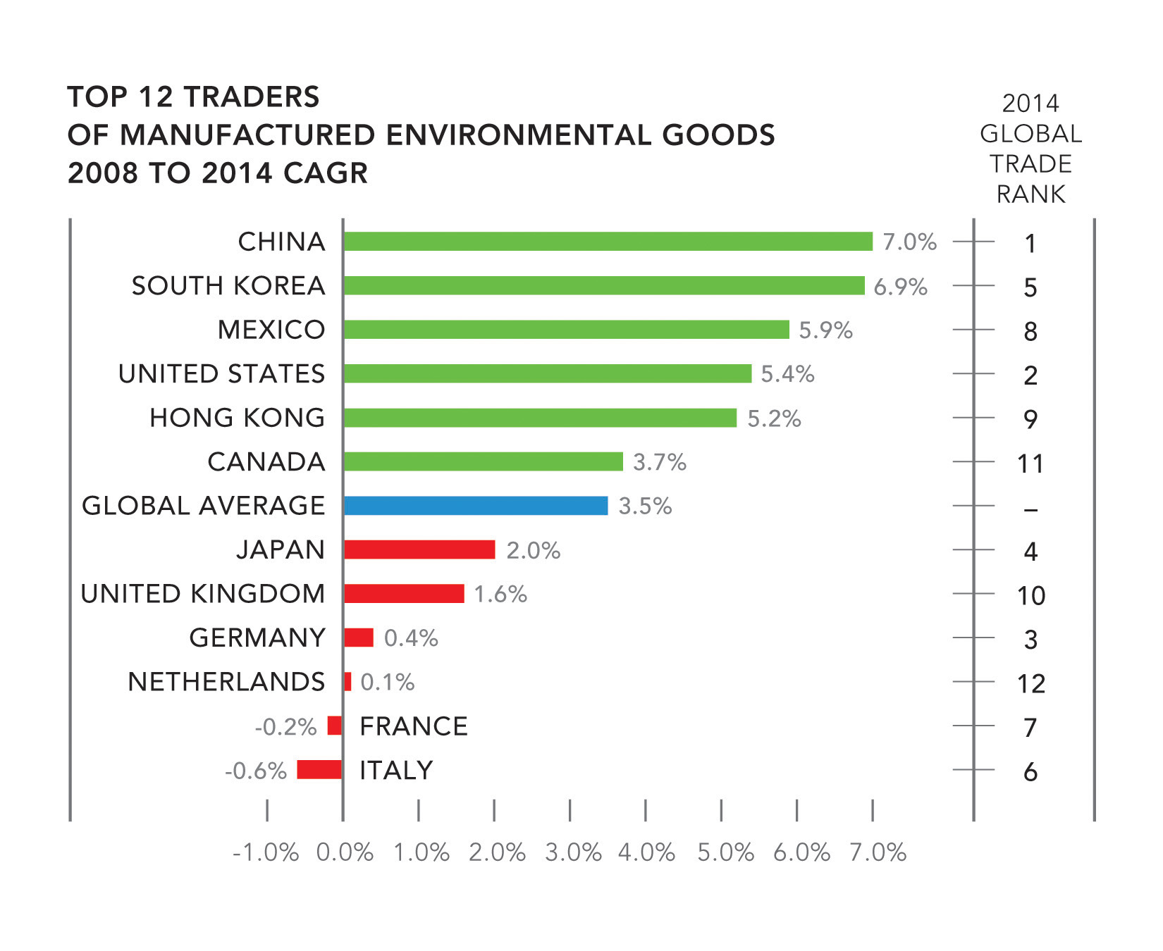

Key findings and challenges from the 2016 Report

Is the party over? No, but it’s time for a reality check

In previous years, we reported industry growth of four times that of the overall Canadian economy. This performance was achieved during a time of declining global GDP and of uneven Canadian GDP growth. Now the mood and the numbers are changing and the competitive environment is getting tougher. Between 2012 and 2014 the industry’s CAGR was less than 1 percent.

Although the Canadian clean technology industry still demonstrated strong resilience in fiscal 2014, the headwinds we predicted in the last report did indeed slow growth, and for the first time there was a decline in industry revenues year over year to $11.63 billion, down from $11.70 billion in 2013.

The Canadian clean technology industry is now moving to the slowest of the three growth scenarios that Analytica Advisors first published in 2011. Projected 2022 revenues under this slow-growth scenario of 5 percent CAGR are $18 billion. This is a long way from a $50 billion industry by 2022 that we proposed as a goal in the 2013, 2014 and 2015 reports.

To reverse this trajectory and get back to the spectacular growth of previous years will require a price on carbon as well as a rethink of innovation, regulation and green infrastructure policies. Equally important, it will require new models to finance the growth of companies including those with high capital requirements.

Despite this news, the industry remains a source of sustainable and growing exports as commodity-led industries face lower demand. And the clean technology industry continues to step up. Revenues from recurring revenue business models are growing, but to sustain this momentum, firms will require access to significantly higher amounts of debt in the form of project finance.

As the industry takes on bigger turnkey projects and as firms scale up, they find themselves constrained by a lack of debt financing. Debt markets have been very slow to form in Canada and Canadian firms are increasingly looking at venture-debt providers, non-domestic banks and international financial institutions for their debt financing.

Canada has a large array of innovation policy and programs, that are now under review for the federal government’s Innovation Agenda. Past programs have produced proven clean technologies that have the potential to deliver broader environmental and economic benefits if climate and environmental regulation, infrastructure and public procurement policies are modernized with innovation in mind. If policy makers can establish a smooth hand off of the baton from the domain of innovation to the domains of regulation and infrastructure, Canada stands to gain a unique advantage in the form of policies that translate public investments in innovation into broadly enjoyed benefits for society. If the baton is dropped, clean technology will go the way of other leading Canadian innovation-based industries that scaled up elsewhere.

The federal budget included $3.4 billion over five years for climate related programs in the form of the Pan-Canadian Clean Growth and Climate Change Plan. This was in addition to the $2.5 billion over five years for Climate Finance. A further $2 billion was budgeted for the Low Carbon Economy Fund and a further $4.3 billion were budgeted over two years for investments in Infrastructure. Each of these programs have dimensions that are relevant to the growth and success of the Canadian clean technology industry.

More well paid, export-driven middle class jobs, but missed opportunities

This sector continues to prove itself as a clean growth foundation for Canada; delivering family-sustaining jobs. There are the kind of jobs that Canada needs to re-invigorate its middle-class to be the home-buyers, consumers and savers of the future. At a time when growth in manufacturing and export-based full-time jobs remains patchy, clean technology continues to out-perform other industries.

Between 2013 and 2014, direct employment in the Canadian clean technology industry grew by 5,700 jobs, to 55,600 jobs. Employment in the clean technology industry now exceeds direct employment in the forestry and logging industries as well as innovation-based sectors such as pharmaceuticals and medical devices.

Even better news is that the industry continues to put young Canadians to work. 11,000 young people already view this as an industry in which they are welcome and needed and are building strong careers. 20 percent of the people working in Canadian clean technology are engineers, but many other roles are represented. However, there are skills gaps in international business development, international sales and capital-raising.

If the industry regains the momentum that delivered 11 percent employment growth in the 2011-2013 period and achieves an 8 percent mid-growth scenario, the industry will employ 100,000 people directly before 2022. And the potential for indirect jobs is greater than we may imagine. Canadian clean technology companies manufacture a full 42 percent of their own bill of materials and source another 25 percent in Canada, representing two thirds of the value of what they produce. This will change over time and materials sourced globally will likely grow, but this is an innovation-driven and globally competitive industry, which will continue to drive manufacturing jobs at home for some time to come.

But if the industry’s employment growth goes the way of revenue, employment numbers will be lower. The 4 percent low-growth scenario for industry employment suggests that the industry would employ 76,000 people directly by 2022, that is 52,000 fewer jobs than the high growth predictions of previous years. That’s 52,000 middle-class, high-value jobs that Canada needs, but may never see.

Canadian financial institutions missing an opportunity?

Financing remains a dominant concern for clean technology companies in Canada. Previous reports have highlighted the need to increase equity investment in Canadian innovation-based industries. If anything the situation is worse with regard to debt financing.

Debt financing is now increasingly important to the growth of a Canadian clean technology industry that is squarely focused on building recurring revenue business models that include turnkey service contracts. As companies move into scale-up, access to debt plays an important role in their ability to deliver on domestic and export business opportunities. And here’s the rub. Canadian banks and financial institutions are not taking up the opportunity, leaving firms to pay 3 to 4 times more than normal commercial lending rates for the debt they need to grow while retaining Canadian control of their companies. There is increasing evidence that international institutions and venture debt providers are moving in to this space to fill the gap left by Canadian charter and policy banks that have not yet stepped up.

Innovative policies to deliver access to debt by technology companies should be considered as a way to gain the productivity benefits of the public investments made in R&D through innovation programs. We need to understand how capital markets would form if municipalities and provinces across Canada could share the risk of including clean technology into infrastructure projects. We asked this question last year, and it hasn’t gone away.

The Low Carbon Economy Fund could provide the means to engage Canadians as investors in clean growth. Could it also provide the 21st century guarantees provided by the Canadian Mortgage and Housing Corporation, which was designed to enable capital formation for the consumer economy? Without back-stopping of risk, municipalities will simply not be able to include innovative solutions as part of their infrastructure investments.

Similarly, Canada must do its part to provide climate finance to countries that need to develop within constrained GHG emissions. But can Canada invest in Climate Finance while also being cognizant of how Canadian clean technology firms can advance sustainable development goals?

These market developments may present both challenges and opportunities for Canadian firms, but there is still a key role for policy makers. Supporting innovation as we have done in the past is not enough.

Still globally ambitious, but not out to rule the world

There are growing signs that, because of increased global competition and the difficulties in securing debt and equity financing for companies, many clean technology companies are refocusing their attention away from dominating global markets.

From 2011 to 2014, the strategic intent of Canadian firms moved markedly away from a strategy focused on dominating global markets. The number of firms moving away from a determination to be dominant, to being globally competitive in niches has nearly doubled from 16 percent to 31 percent. But Canadian clean technology firms have much less interest in becoming mere suppliers in global value chains and building to specification. Instead, they are still very much focused on developing and delivering complete solutions, albeit with a greater focus on niche markets.

Supporting these ambitions will require better integration between provinces and the federal government in policy discussions. Federal and provincial infrastructure investment initiatives will also need to consider the role of newly commercialized solutions. For example, federal infrastructure investments in water and wastewater could be designed to provide market access for innovations, which can then be sold overseas. Since 1958, the US has had legislation that requires SME procurement to be part of all public procurement as well as all procurement by firms receiving significant public contracts. Canada needs its own approach.

Still an export-fuelled industry with lots of untapped growth potential

For the first time in this series of reports, exports exceeded domestic revenues and reached $6.6 billion or 57 percent of revenues. Up significantly from 50 percent in 2013. 23 percent of exports were to non-US markets. The industry now estimates that exports, as a percentage of total industry revenues, will grow from 57 percent in 2014 to 66 percent in 2016.

Reflecting the decline of the Canadian dollar in 2014, the proportion of companies actively exporting grew to 87 percent during 2014, up from 68 percent during 2013. The industry’s forecast for the next two years is ambitious, with 91 percent of companies expecting to be actively exporting in 2016. It will be interesting to note if the industry achieves this stretch goal, given global markets dynamics, growth of the US economy, policy changes and currency fluctuations.

That said, Canadian clean technology companies are clearly accomplished exporters. What is still a cause for concern is whether they have access to domestic market opportunities and debt finance as a springboard to build strong international credentials in the delivery of complete solutions. Investment in modernized regulation and financial innovation will be required to accomplish this.

With no sign of a global clean technology slowdown and likely acceleration following the Paris Agreement, there is clearly a lot more potential for Canada. In the low-growth scenario, exporting 70 percent of industry revenues would represent $12 billion in exports by 2022. A mid-growth scenario would be in the order of $19 billion. Declining market share in Canadian exports of clean technology would suggest the mid-growth scenario goal may now also be too challenging. We have fallen behind Singapore, Spain, Czech Republic, Denmark and Poland and other countries are hungrier and closer to the action. The burning question is whether Canada can turn it around, grow market share and once again attain its fair share of global trade in clean technology?

Will others benefit from Canada’s R & D investment?

The industry’s cumulative investment in R&D was $7.6 billion for the period from 2008 to 2014. Of this, $5.5 billion in R&D investments were from firms with less than $50 million in annual revenues. The question remains whether firms are making themselves into the classic takeover target for foreign-owned companies who can then profit from Canadian investments in innovations?

Innovation-based firms invest in R&D rather than fixed assets, which will affect their access to asset-based lending and therefore their ability to deliver fully financed turnkey systems. If all the financing goes into R&D, what’s left to finance growth? Indeed, only the most R&D intensive healthcare sector invests more as a percentage of revenue. While there is evidence of a slowdown in clean technology R&D, we believe there may still be cause for concern.

In the absence of coordinated domestic regulation and finance innovation, push-based innovation policies risk creating an R&D bubble. And as more R&D is invested in the industry, companies without solid domestic bases will be sold/acquired.

Elsewhere, countries such as Germany, Japan, China and South Korea are moving with whole-of-government conviction, based on their assessment of market opportunity. These countries have achieved competitive results with their investments in innovation policy. It’s time for Canada to take note.

2016 Recommendations

Context for the 2016 Canadian Clean Technology Report Recommendations:

- Recognizing that mitigating and adapting to climate change requires changes to existing systems to protect the air, water and land;
- Recognizing that replacing fossil fuel exports now representing 20 percent of all of Canadian exports with globally competitive goods will require time;
- Recognizing that Canada has many firms whose innovative goods and services protect the air, water and land and deliver export-led economic growth;
- Recognizing that regulatory, financing, innovation, infrastructure systems are evolving to meet the needs of society, the environment and the economy, and
- Recognizing that Canadians support both acting on climate change and diversifying the economy

We make the following recommendations:

Stimulate deployment of commercialized clean technology innovation through combined policy tools:

- Implementing a substantial and rising price on carbon. This will send a signal to all economic actors to examine risk associated with energy and fossil-fuel business inputs;
- As the initial price on carbon will be too low to stimulate take up of all innovations that are ready to deploy, implement regulation in selective industries based on performance standards and the concept of Best Available Technology;
- Implement policy to enable greater access by innovators to public procurement as pathway to their participation in high visibility projects including green infrastructure;
- Level the playing field with fiscal policy that takes full account of treaty and G20 commitments.

Finance the deployment of clean technology innovation based on the following:

- Coordinate the formation of capital markets with the formation of markets (see A through D);
- Stimulate consumer savings by enabling Canadians to buy government sponsored green bonds via the Low Carbon Trust Fund (LCTF). Establish clean innovation criteria for the LCTF;
- Deploy public capital to back-stop risk for buyers and sellers of clean innovation;
  - Back-stop risk born by buyers: Enable cities and provinces to share risk associated with procuring clean innovation;
  - Back-stop risk born by sellers: Enable firms to share risk associated with selling projects through scaled up performance bonding and debt guarantees;
  - Financial innovation for climate finance: Deploy climate finance and overseas development assistance as a backstop to private capital. For example, enable development banks to guarantee PPAs by utilities in developing countries.

Invest in the next generation of innovation by doubling current investments doing so with two policy tests:

- What is the Canadian commercial capacity for new innovation investments?
- What are the global commercialization partnership opportunities?
It is quite clear that Canada and Canadians can make a significant difference in the growth of this sector through the application of powerful policy levers. As the 2016 report indicates, we can and should build a significant economic sector, relevant across the country, through coordinated and patient policies.

With the decline of Canada’s global market share in Environmental Goods, we wonder if Canada can aim to achieve a 2 percent global market share in clean technology. Canada accounts for 2% of the global economy, that that would be our “fair share.” Although overall we punch above our weight and Canada holds 2.6 percent of global trade. If 2% was achieved, Canada could create a $50 billion industry by 2022, to the immense benefit of our economy and society. To build this globally competitive, multi-billion dollar industry, we would need to nurture dozens of Canadian clean technology companies that have attained $100 million in revenue. This was our clarion call six years ago when the first research was completed. It remains a worthy goal for Canada today. We have made a powerful beginning and set an ambitious goal. But we are suffering a setback and growth is stalling. What next steps are we ready to take to rediscover the growth path and capitalize on a once in a lifetime opportunity?

